Slide 1

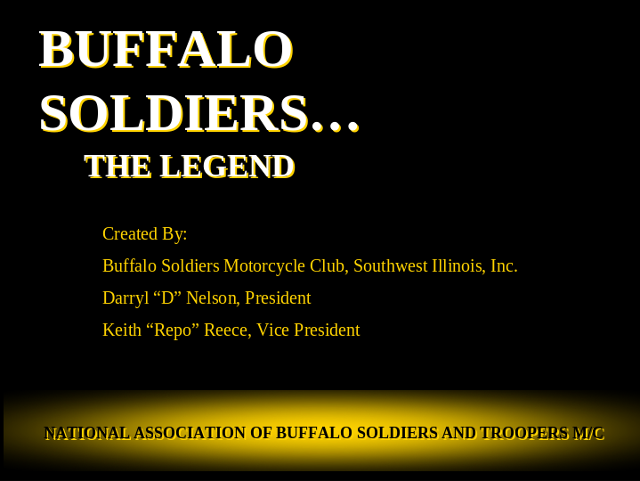

Slide 2

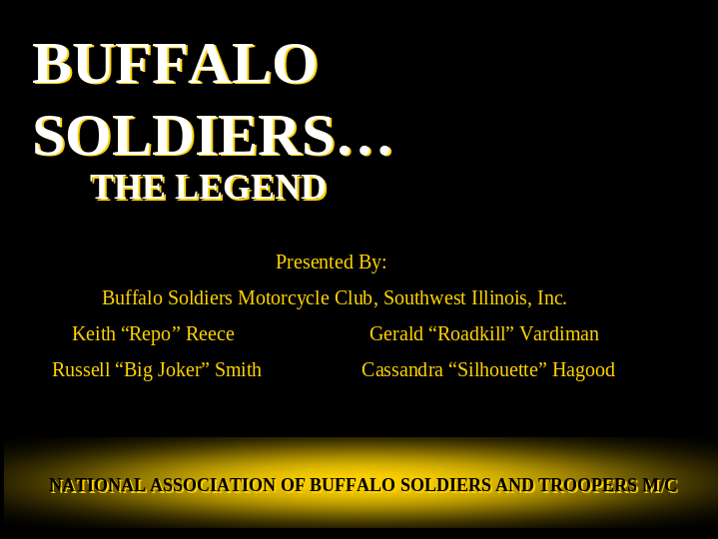

Slide 3

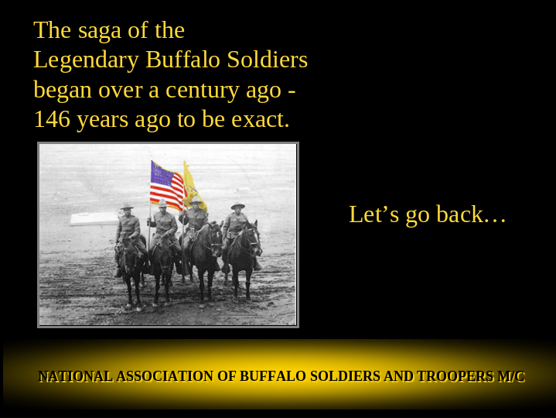

Slide 4

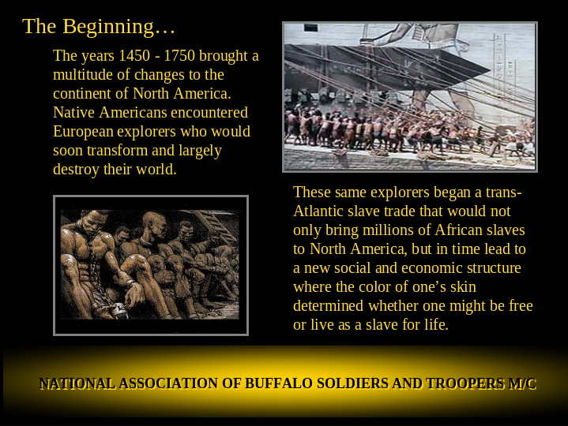

This briefing starts with the arrival of Blacks to America to America via the Atlantic slave trade. Records state that the first Blacks to arrive here came in 1619 on a Dutch ship that was caught out at sea in a violent storm. The ship's cargo hold is empty except for twenty or so Africans whom the captain and his crew have recently robbed from a Spanish ship. The captain exchanges the Africans for food, then sets sail.
It's not clear if the Africans are considered slaves or indentured servants. (An indentured servant would be required to work a set amount of time, then granted freedom.) Records of 1623 and 1624 list them as servants, and indeed later records show increasing numbers of free blacks, some of whom were assigned land.
Whatever the status of these first Africans to arrive at Jamestown, it is clear that by 1640, at least one African had been declared a slave. This African was ordered by the court "to serve his said master or his assigns for the time of his natural life here or elsewhere."

Slide 5

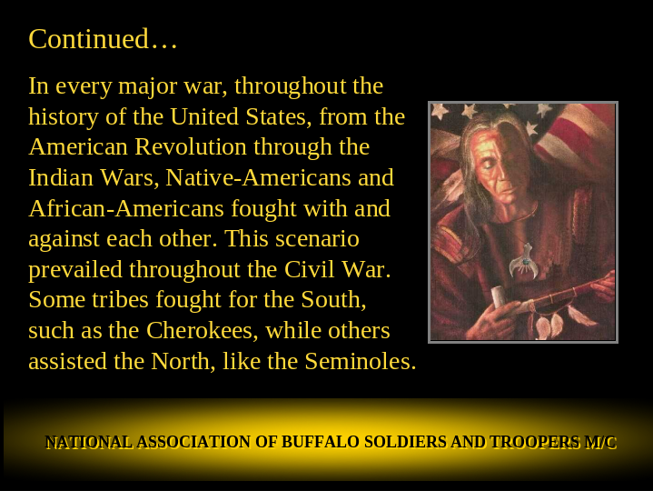

The Boston Massacre, was an incident on March 5, 1770, in which British redcoats killed five civilian men. Three Americans — ropemaker Samuel Gray, mariner James Caldwell, and a Black sailor named Crispus Attucks — died instantly. Two others died later from their wounds. This sparked the rebellion in some of the British American colonies, which culminated in the American Revolutionary War. Attucks was the first Black man to die fighting for this country.

Slide 6

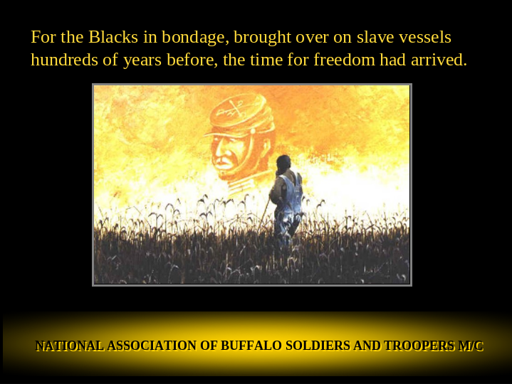

The call for Blacks to fight with the Union extended across the country. Illinois was yet to be a State when free Blacks began to settle here. The oldest Black church in the state was formed in 1809, right here in St Clair County, nine years before statehood.

Slide 7

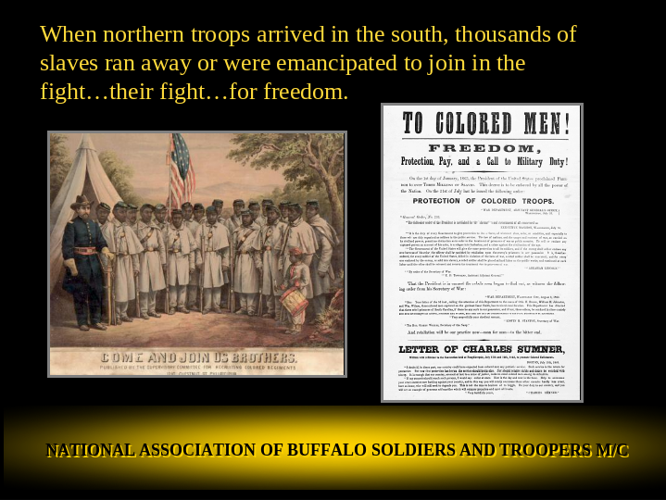

To Colored Men, FREEDOM. Protection, Pay, and a Call to Military Duty. On the first day of January 1863 the President of the United States proclaimed freedom to over three million of slaves Blacks.
This was surely desperate times.
Lincoln stated that the nation and the customs of war as carried out by civilized powers permit no distinction as to color in the treatment of prisoners of war as public enemies.
Black men from all over the country answered the call to serve.

Slide 8

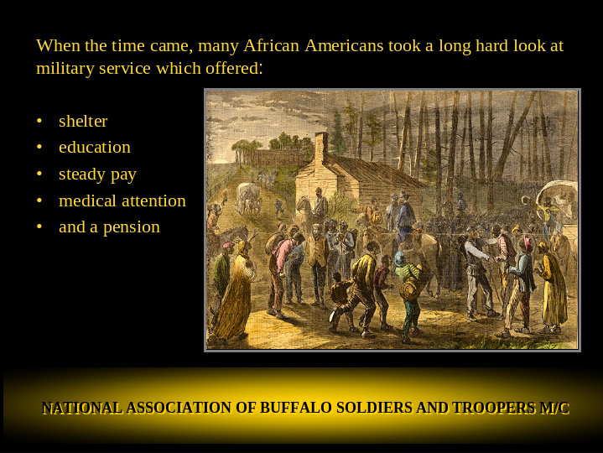

Jack Johnson, a resident of East Carondolet, IL served in the 6th Heavy Artillery Regiment US Colored Troops, the predecessors to the Buffalo Soldiers. He was used to recruit slaves by the Union Army and served in the Artillery with the United States Colored Troops. He fought until the end of the war and is buried in the Flat Creek Missionary Baptist Church cemetery along with another soldier from the Civil War.

Slide 9

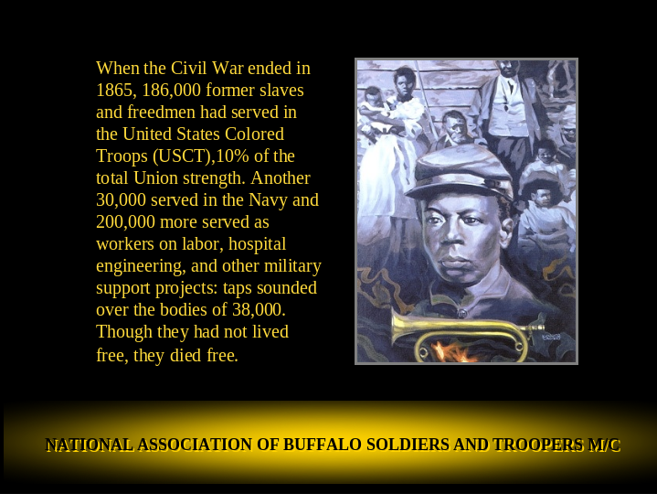

At the close of the Civil War soldiers of the 62 United States Colored Infantry who were stationed at Fort McIntosh, Texas took steps to establish an educational institution in Jefferson City, MO which they named Lincoln University. The school founders stipulated that the school shall serve to benefit the recently freed slaves, shall be located in the state of Missouri, and its fundamental idea was to combine study and labor. On January 14, 1866 the school was established.

Slide 10

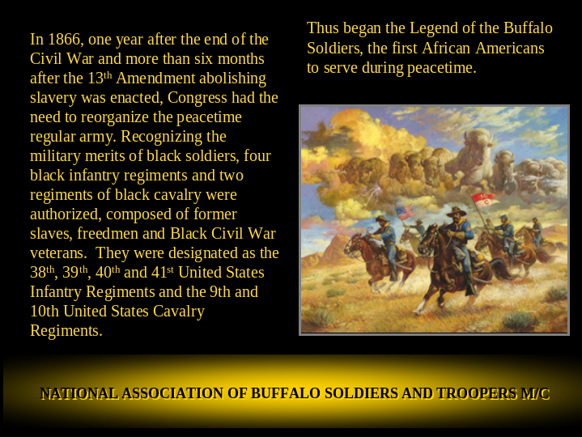

That same year Congress organized a peacetime Army and it was decided that free Black men could serve in six units. Four Infantry and two Cavalry were formed and thus began the history of the Buffalo Soldiers. Our club follows the history of two of these units, the 9th and 10th Cavalry Regiments.

Slide 11

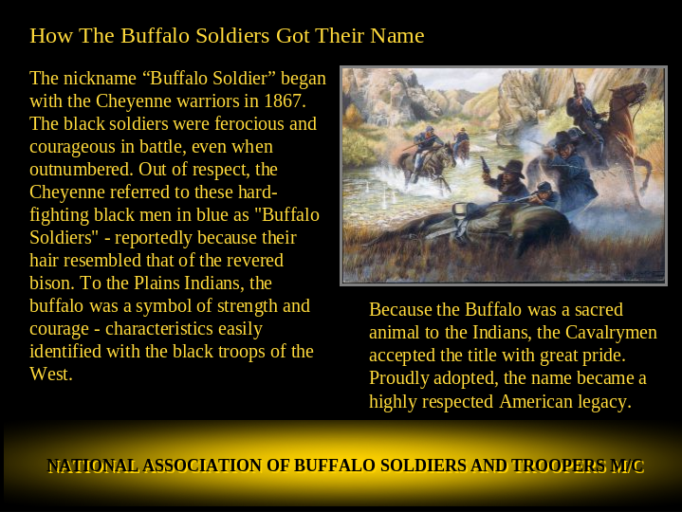

As we can see by the name that these Black fighting men were given, they were well respected by the people that they faced in battle.

Slide 12

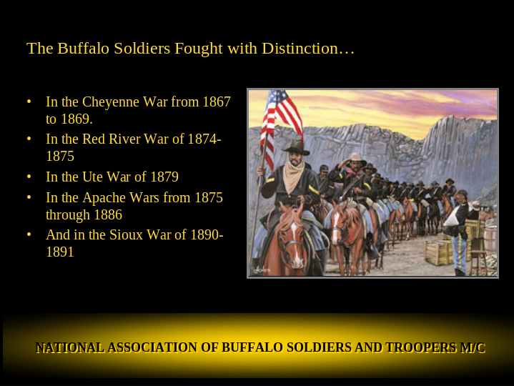

Here a some of the campaigns that they serve in.

Slide 13

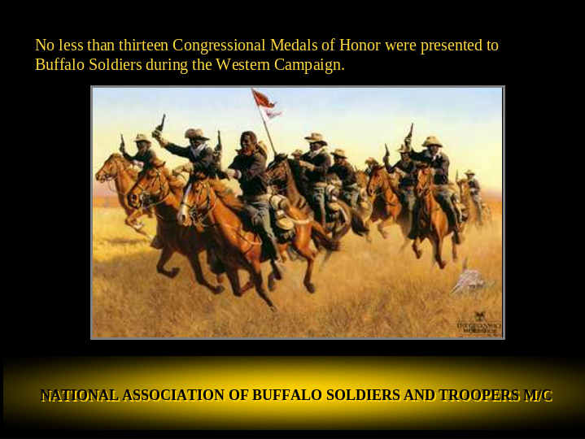

They fought with courage and served with honor.

Slide 14

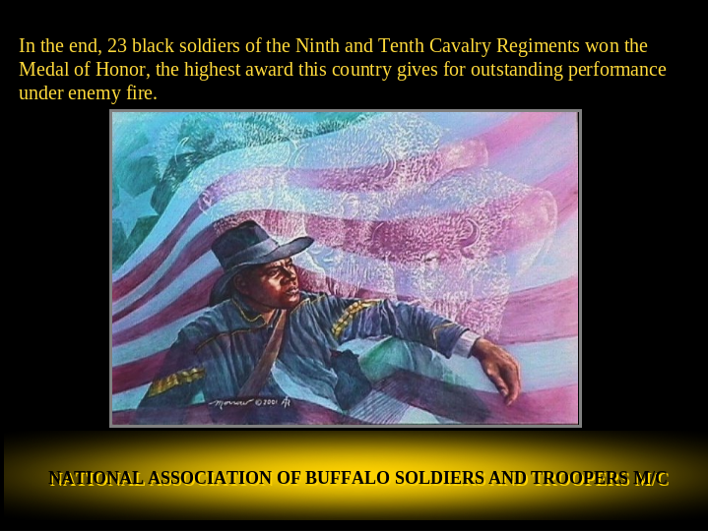

In all, twenty three black soldiers of the 9th and 10th were awarded the Medal of Honor

Slide 15

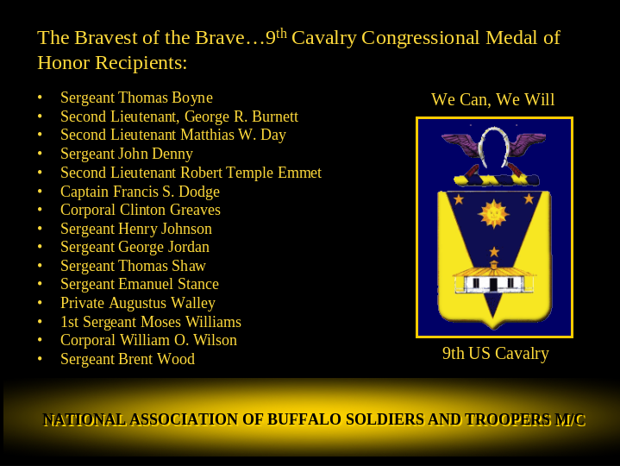

Here are the names of recipients from the 9th – We Can, We Will!

Slide 16

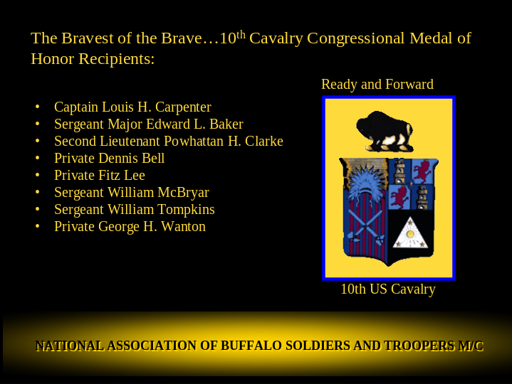

And the 10th – Ready and Forward

Slide 17

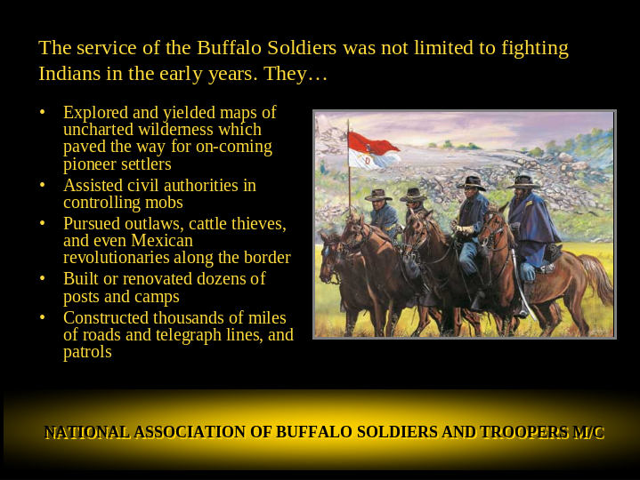

These are some of the many tasks they performed

Slide 18

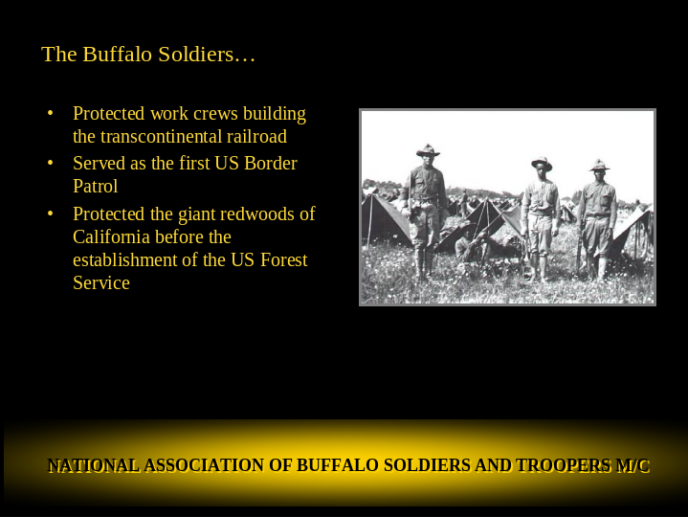

Same

Slide 19

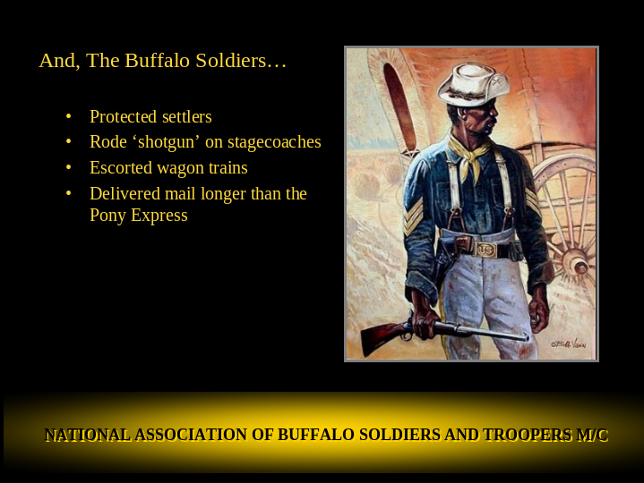

Same

Slide 20

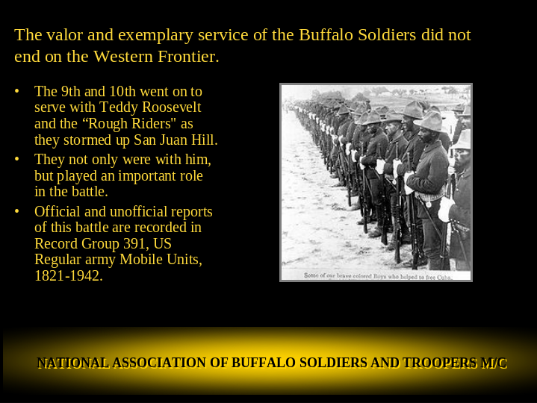

They fought in the Spanish American War in July of 1898 with Teddy Roosevelt's Rough Riders charging up San Juan Hill in Cuba. By then there were just 4 Black Regiments and they all served in Cuba. They were the 9th and 10th and the 24th and 25th Infantry Regiments. Buffalo Soldiers fought in the biggest battles. Five were awarded the Congressional medal of honor for their valor. In August the US started a piull out of Cuba but the evacuation was not total. The U.S. Army kept the black Ninth Infantry Regiment in Cuba to support the occupation. The logic was that their race and the fact that many black volunteers came from southern states would protect them; this logic led to these soldiers being nicknamed “Immunes”. Still, by the time the Ninth left, 73 of its 984 soldiers had contracted Yellow Fever which was the main reason to withdraw the Army from Cuba as many soldiers contracted the disease.

Slide 21

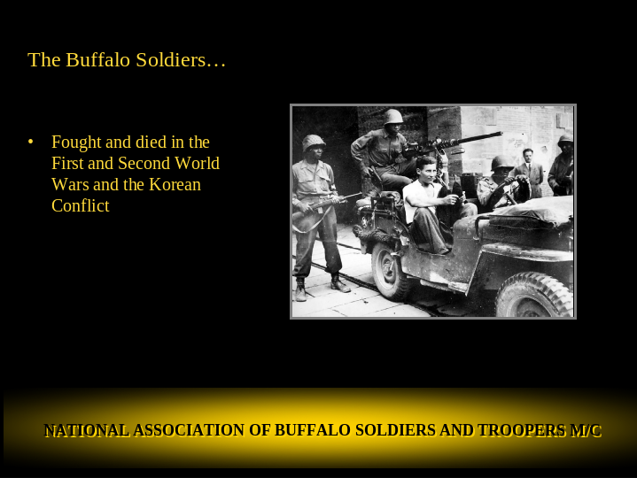

The history of Black Fighting Men continued through all the conflicts the US fought in.

Slide 22

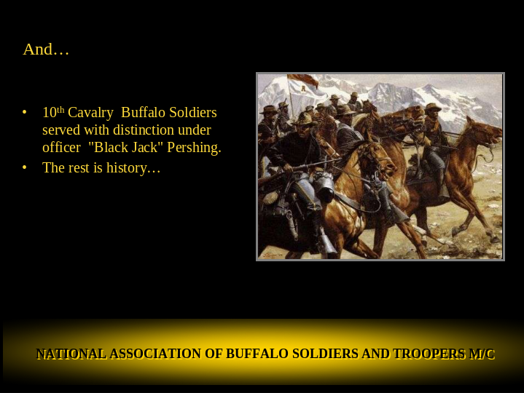

General of the Armies John J. Pershing is a controversial figure regarding the Buffalo Soldiers. He served with the 10th Cavalry from October 1895 to May 1897. He served again with them for less than six months in Cuba. Because he saw the "Buffalo Soldiers" as good soldiers, he was looked down upon and called "Nigger Jack" by white cadets and officers at West Point. It was only later during the Spanish-American War that the press changed that insulting term to "Black Jack." [22] During World War I Pershing bowed to political and progressive racial policies of President of the United States Woodrow Wilson, Secretary of War Newton D. Baker and the southern Democratic Party with its "separate but equal" philosophy. For the first time in American history, Pershing allowed American soldiers (African-Americans) to be under the command of a foreign power

Slide 23

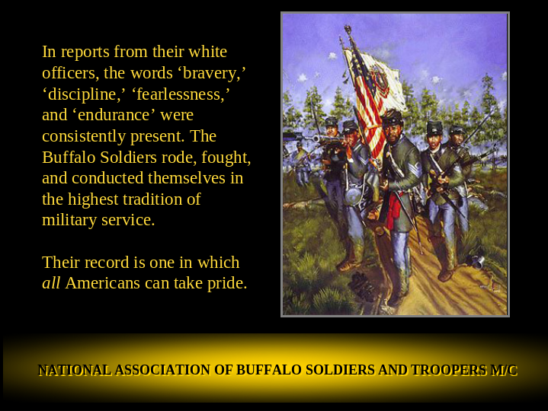

Where ever they served, they served with pride as professional fighting men.

Slide 24

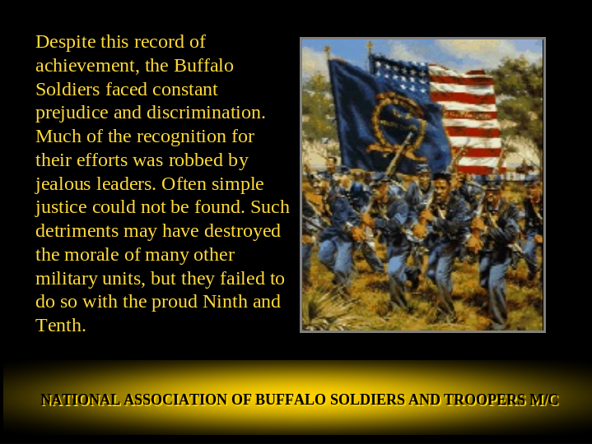

They served in spite of the prejudice and unfair treatment they face on a daily basis.

Slide 25

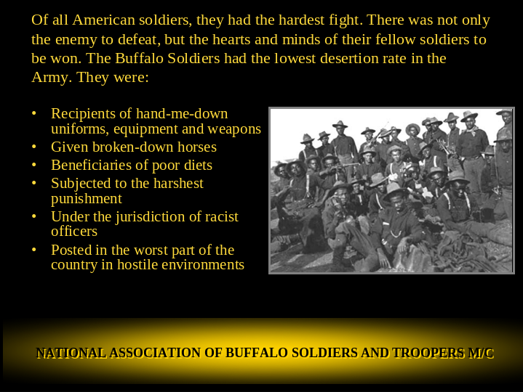

This was compounded by the fact that they were issued the worst equipment, broken-down horses and fed a poor diet.

Slide 26

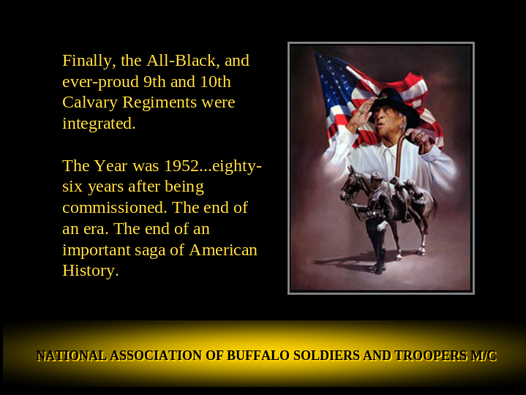

The separate but equal period finally came to an end when in 1952 the 9th and 10th were integrated.

Slide 27

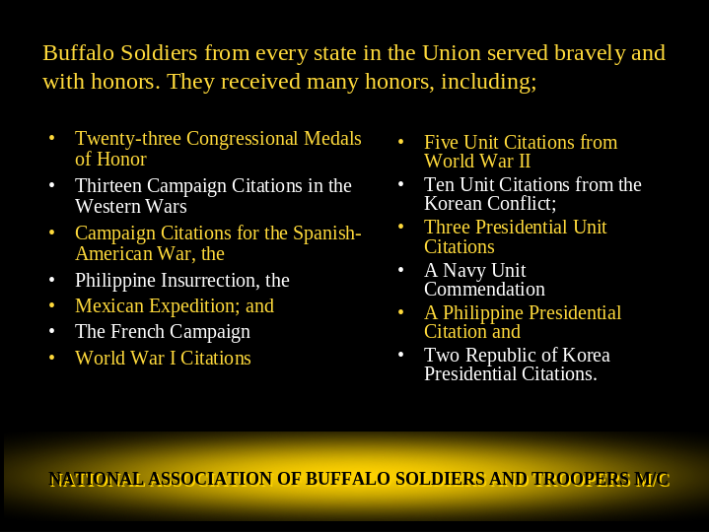

Here are some of the many honor they received

Slide 28

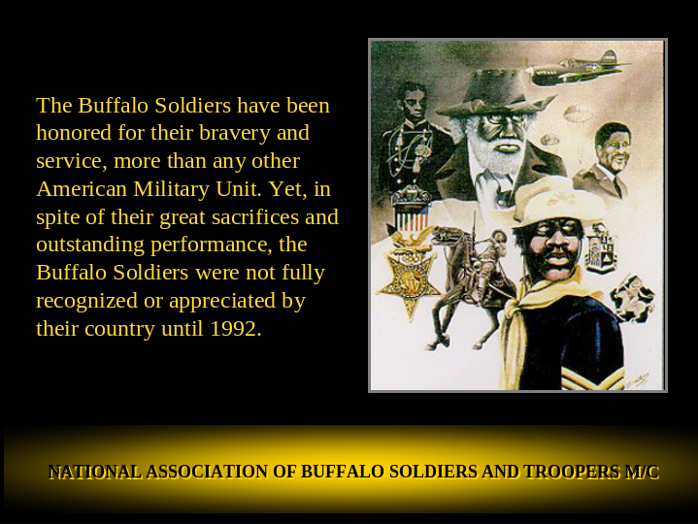

They were some of the most decorated units to serve but they were not really recognized by their country until 1992. Most will say that their full story has yet to be told. How many of you were taught about them in school or have seen them in the westerns that we’ve watched on TV and in the movies?

Slide 29

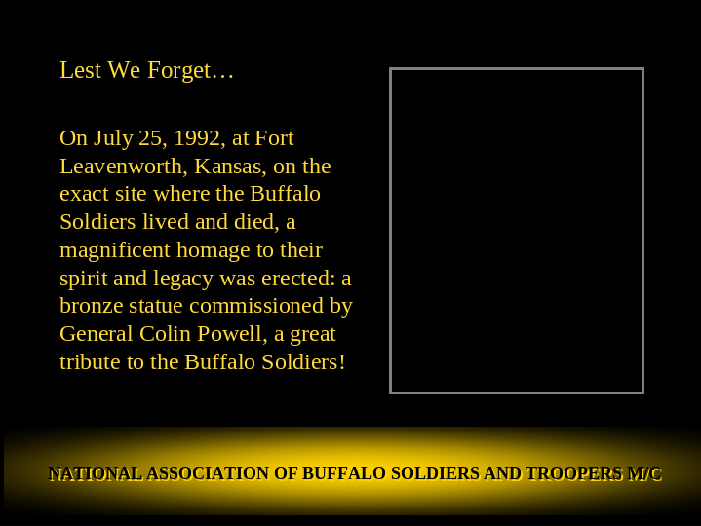

Their moment to shine was near. In 1992 at Fort Leavenworth, Kansas, the very place where the 10th was formed on Septembe2 21st, 1866, a monument was erected in their honor.

Slide 30

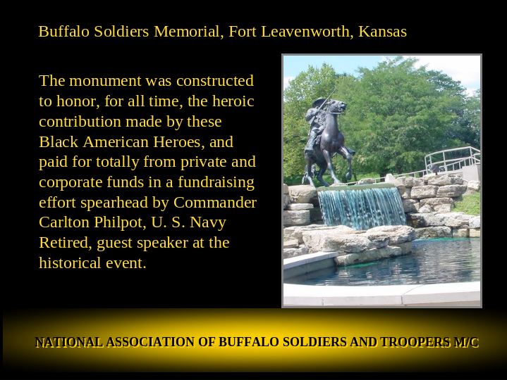

General Colin Powell, the highest ranking member of the US military at the time did the unveiling.

Slide 31



